|  |
| --- |
|    * A school in the heart of the town. * Before and after school clubs. * Creative, engaging curriculum. * Spacious grounds. * Caring Christian environment where we promote ‘Everything is possible for one who believes.’ Mark 9:23   DREAM - BELIEVE - ACHIEVE |
| Call us for more information on 01536 722757  St Mary’s Primary Academy  High Street, Burton Latimer, NN15 5RL  www.stmaryscebl.info |

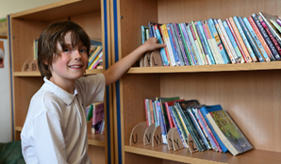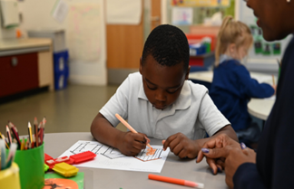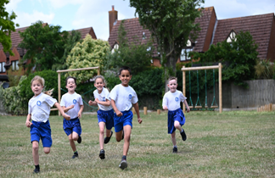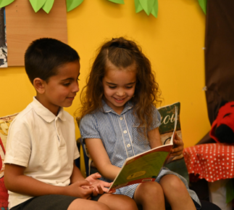

*“St. Mary’s is a welcoming and inclusive school, where there are caring relationships between staff and pupils. Pupils are happy and feel safe in school..”* Ofsted inspection feedback, May 2023.